Community Building in Clongriffin/Belmayne - Research Proposal
Northside Partnership, in collaboration with the City of Dublin Youth Services Board, seeks submissions from suitably qualified researchers to conduct a targeted piece of research focusing on opportunities for community building in Clongriffin/Belmayne (Dublin 13).
Background to the Areas:
The Clongriffin and Belmayne areas grew following the publication of Dublin City Council’s North Fringe Action Plan (DCC, 2000). Since 2000 both areas have seen massive growth however this halted for several years following the economic crash in 2008. More recently development has resumed with the building of new housing and apartment units on a large scale. While the area has public amenities such as playgrounds and parks, there is no community run facility that can cater for the surrounding population. Residents of Clongriffin/Belmayne have been actively organising events for their community and they have worked with other organisations including Dublin City Council in developing and promoting events.

Anecdotal information suggests that anti-social behavior may be on the increase and that while there are a significant number of high-income families and individuals there is also a significant number of lower income families who are experiencing hidden disadvantage. Furthermore, it is understood that a significant number of properties within the area, while in private ownership, are rented to tenants in the private rental market.
Purpose of the Research:
The primary purpose of this research is to gather data and evidence as to the needs of the Belmayne/Clongriffin areas regarding community and social service provision and in particular services and supports available to young people across the area. The findings of this research will be used by Northside Partnership and the City of Dublin Youth Services Board to advocate for service provision where needs or concerns have been identified. More specifically we anticipate that, through this research, a strong case will be made for greater provision of services for young people in the Belmayne/Clongriffin areas will be submitted to CDYSB and the Department of Children, Equality, Disability, Integration and Youth (DCEDIY).
In commissioning the research, both Northside Partnership and the City of Dublin Youth Services Board, wish to utilise creative research approaches that help to bring the community together, consults with residents at a meaningful level, contributes to the building of social capital and builds skills and capacity within the community to advocate on their own behalf and utilises available assets effectively.

It is anticipated that the work will entail both qualitative and quantitative research approaches. For the former we suggest holding community consultations and to map out possible local integrated service responses for young people that will offer opportunities, co-ordinate effort, and disrupt the potential for young people to take part in activities that may negatively impact upon their life chances.
In conducting the research, it is anticipated that the researchers will assess available demographic data to develop a holistic picture of the area. However, it is acknowledged that this may present a challenge in that the last census was conducted in 2016 and the area has experienced new growth since that time. This lack of recent data, coupled with the diverse population on socio-economic levels, results potentially in hidden deprivation levels. The high level of ethnic diversity is also a key feature of this area. Consequently, it is critical that all potential sources of data, publications, reports etc. be utilised to develop as complete a picture of the areas as possible.
Using innovative/participatory research methodologies, the scope of this research is defined as:
- Compile a socio demographic profile of the population in the Clongriffin/Belmayne ED’s
- Conduct a profile of the geographical area.
- Map service provision and youth specific services and provide a profile of services available to young people in the 10– 24 age range in the local area.
- Through collating data from residents and key stakeholders identify the main social issues affecting residents in the area
- Produce a categorisation of young people’s involvement with drugs/Crime (10-24 age range) based on interviews with key stakeholders.
- Explore the need for community services and youth services in the areas
- Mapp existing assets and capabilities within the community
- Explore potential community/ youth centre spaces within the areas.

Other Considerations
- Geographical Area (See Appendix 1 Map Below)
The research area is bounded by the R123 to the North, the Railway Line to the East, the R139 to the South and the Malahide Road to the West.
- Timeframe:
Commencing research in May 2021 to be completed by October 2021.
Given the current Covid-19 context it is anticipated that the research will commence in May 2021 with the primary focus being on desk-based research, consultations with key stakeholders etc. This will allow for the preparation and development of more qualitative research approaches that can be deployed, as Covid-19 restrictions reduce, to engage with the community.
- Oversight committee:
An oversight committee comprised representatives of Northside Partnership and the City of Dublin Youth Services Board will meet with and support the successful candidate in implementing the research. It is anticipated that four meetings will take place at critical times in the research cycle. These may include but are not limited to:
  - Research Initiation,
  - Completion/Review of desk-based research, and qualitative/creative proposal
  - Review of initial findings, draft report headings
  - Review of final report

- Budget:
A maximum of 12,000 euro will be made available to complete this research.

Selection Criteria
Suitably qualified applicants are invited to submit a detailed response addressing each element of the (6) selection criteria as noted below and submit a CV detailing their experience and qualifications.
- Experience of Innovative participatory research methodologies.
- Experience of writing high quality research reports for multi-sectoral audiences.
- Experience of engaging with diverse communities.
- Outline your deliverables and timelines for each element of the research as outlined in the proposal.

- Cost for Delivery of the research (please itemise per element).
- Please tell us why you think you would be the best candidate for this contract? (max 400 words)
Please note selectionis based on information supplied in the selection criteria along with your CV. Unfortunately, responses who do not address the selection criteria above will not be considered. Therefore, it is very important that candidates describe their experience considering those requirements in their application.
Northside Partnership and the City of Dublin Youth Services Board will review all completed applications and NSP will appoint the provider on a consultancy basis.
To apply please click on the link below. Please select the appropriate position from the drop-down list, complete the form and upload Selection Criteria and your CV.
Closing date: May 5th 2021@5:00pm
To Apply Click Here
Northside Partnership is an equal opportunities employer

Appendix 1 – Map of Research Area
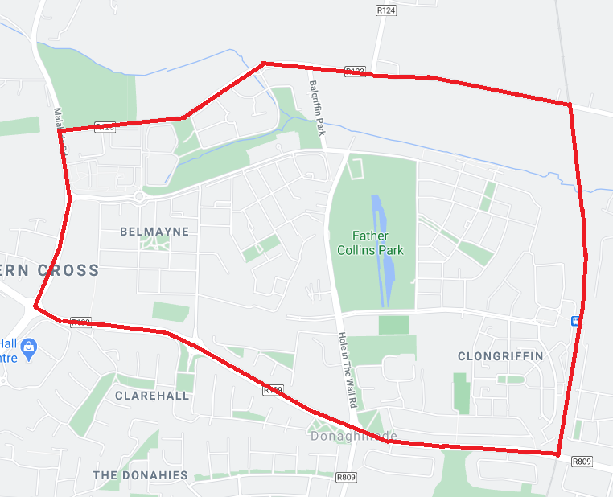

Note: there are a number of facilities that can be accessed by the community on a needs basis however these facilities do not have an anchor tenant to manage them.
The next census was planned to take place on 18th of April 2021 has been moved to 3rd of April 2022 because of COVID-19.
Note: In exploring the need for community and youth services consideration should be given to the potential catchment areas for services, access issues, community/neighbourhood boundaries etc.

